**Topics: Descriptive Statistics and Probability**

1. Look at the data given below. Plot the data, find the outliers and find out $μ, σ, σ^{2}$

|  |  |
| --- | --- |
| **Name of company** | **Measure X** |
| Allied Signal | 24.23% |
| Bankers Trust | 25.53% |
| General Mills | 25.41% |
| ITT Industries | 24.14% |
| J.P.Morgan & Co. | 29.62% |
| Lehman Brothers | 28.25% |
| Marriott | 25.81% |
| MCI | 24.39% |
| Merrill Lynch | 40.26% |
| Microsoft | 32.95% |
| Morgan Stanley | 91.36% |
| Sun Microsystems | 25.99% |
| Travelers | 39.42% |
| US Airways | 26.71% |
| Warner-Lambert | 35.00% |

**Ans:**

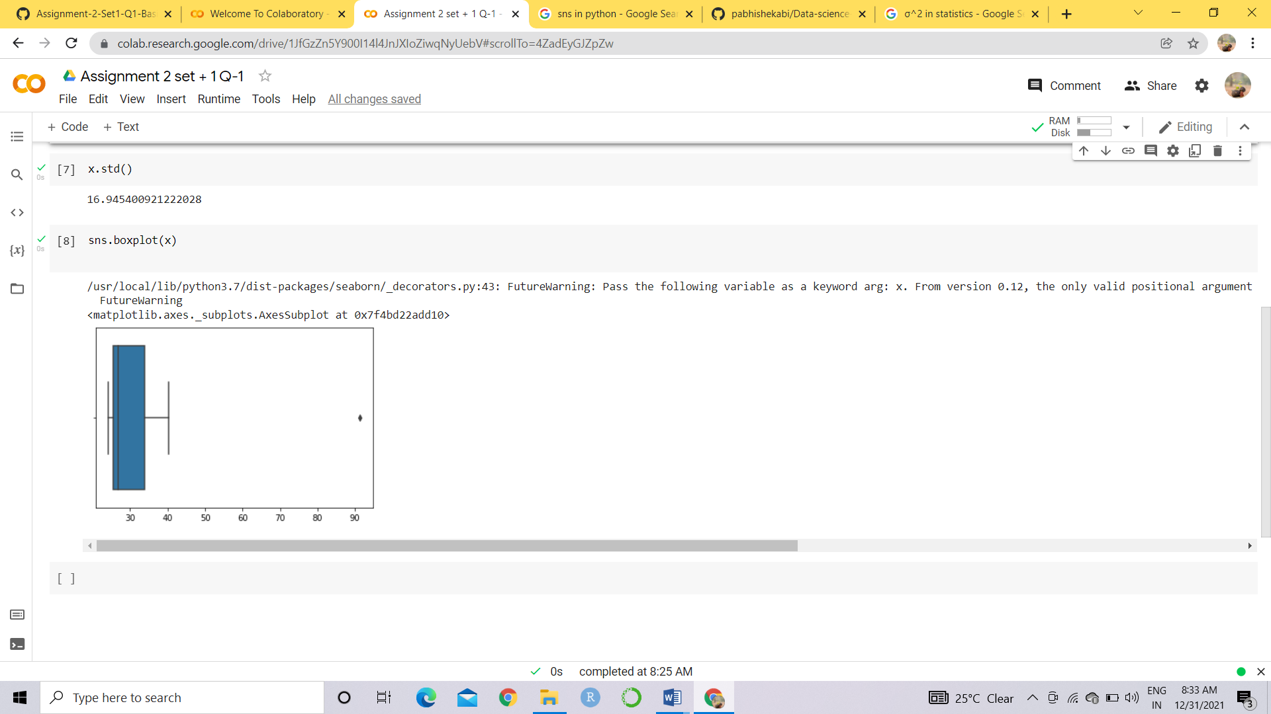

Mean = 33.2713

Standard Deviation = 16.9454

Population Variance = 287.14

Outliers = 91.36%



Answer the following three questions based on the box-plot above.

1. What is inter-quartile range of this dataset? (please approximate the numbers) In one line, explain

what this value implies.

**Ans:** Inter- quartile range (IQR) = (12-5) = 7

Here half of the data lies in the IQR and IQR is equal to the Median

1. What can we say about the skewness of this dataset?

**Ans:** It is a Positively skewed dataset.

1. If it was found that the data point with the value 25 is actually 2.5, how would the new box-plot

be affected?

**Ans:** There will be decrease in the skewness and there wont be any outliers.



Answer the following three questions based on the histogram above.

1. Where would the mode of this dataset lie?

**Ans:** Mode lies between 4 and 9

1. Comment on the skewness of the dataset.

**Ans:** It is a right skewed or Positive skewed dataset

1. Suppose that the above histogram and the box-plot in question 2 are plotted for the same dataset.

Explain how these graphs complement each other in providing information about any dataset.

**Ans:** Boxplot and histogram used to find median ,skewness and outliers

We have 25 as outlier and dataset is right skewed

1. AT&T was running commercials in 1990 aimed at luring back customers who had switched to one of the other long-distance phone service providers. One such commercial shows a businessman trying to reach Phoenix and mistakenly getting Fiji, where a half-naked native on a beach responds incomprehensibly in Polynesian. When asked about this advertisement, AT&T admitted that the portrayed incident did not actually take place but added that this was an enactment of something that “could happen.” Suppose that one in 200 long-distance telephone calls is misdirected. What is the probability that at least one in five attempted telephone calls reaches the wrong number? (Assume independence of attempts.)

**Ans:** Probability of one misdirected call among 200

P(C) = 1/200 = 0.005

Probability of not wrong call:

1 - P(wc) =1- 1/200 = 0.995

Probability of at least one out of five is a wrong number

= 1 – Probability that all five calls are not wrong numbers

= 1 – (1 – P(C))^5

= 1 – (1- 0.005)^5

= 1 – 0.975

= round(0.02475)

= **2.5% chance**

1. Returns on a certain business venture, to the nearest $1,000, are known to follow the following probability distribution

|  |  |
| --- | --- |
| x | P(x) |
| -2,000 | 0.1 |
| -1,000 | 0.1 |
| 0 | 0.2 |
| 1000 | 0.2 |
| 2000 | 0.3 |
| 3000 | 0.1 |

1. What is the most likely monetary outcome of the business venture?

**Ans:** 2000 has 30%

1. Is the venture likely to be successful? Explain

**Ans:** It can be said by plotting histogram, which is positively skewed

The venture is successful because the probability of return is 60%

1. What is the long-term average earning of business ventures of this kind? Explain

**Ans:** Average = 800

1. What is the good measure of the risk involved in a venture of this kind? Compute this measure

**Ans:** Variance =3500000

Std dev =1870.829

The venture is risky because the standard deviation is high.